

**PUSL2019 Information Management and Retrieval**

**Coursework**

### **Group Name: IMR group AY**

Members:

| ID | Name | Degree Program (SE/CN/CS) |
| --- | --- | --- |
| 10953275 | Deegoda Liyanage Chanithu Disaga Rithmal | SEC |
| 10953295 | Athukoralage Don Nuran Dinuwara Athukorala | SEC |
| 10953271 | Mallika Arachchige Senithu Ranmeth Perera | SEC |
| 10953292 | Dasilige Nohim Seth Sri Senanayake | SEC |
| 10953269 | Sihal Sanwiru Jayawickrema Wijethunge | SEC |
| 10953264 | Rovin Sandipa Dompage | SEC |
| 10953217 | Haputhanthirige Yasiru Nethmina Haputhanthiri | SEC |
|  |  |  |

*Section 1*

**Introduction**

Today’s world is full of competition in retail and supermarkets must have some systematic and effective way of managing their day-to-day activities. Research will be centered on the creation and strengthening of a specialized POS system that will handle customer management, stock, discount, sales and reporting. The purpose of this project is to design database systems using Microsoft SQL server such that all the data have a very high level of integrity and accuracy for decision making by the supermarket and generate the reports of a day to monthly reports.

***Customer Management***

**Store Information**: The flow is for where customer name and his or her contact details i.e. phone number and all their purchase history in so as to sync the service / or marketing angle with a target customer.

**Loyalty Programs**: Some features of the usage of loyalty points and rewards will help to reduce, and at the same time increase the frequency of return and customers’ loyalty respectively.

***Stock Management***

**Stock Levels**: However you can go moderate, but you just need to count on how many of everything there is, order points which you set so that it gives a signal that you should order for more of the stock. You are also able to decide how much detail about your supplier you wish to input along with when the stock comes back then it is back into the store.

**Product Details**: The concept is to be all embracing and must be inclusive of the list of the product categories, the prices each carries, the barcodes and brief descriptions required when conducting actual physical stock take of the above products.

***Discount Management***

**Discount Schemes:** It helps you in managing offer such as seasonal sale offer, offer with bulk purchase, special offer etc with an aim of attracting the customer to buy more.

***Sales Management***

**Sales Data**: Make the records of each sale as detailed as possible by recording good types, quantities sold, their prices and the means of payment made.

**Sales Analysis**: Daily sales to generate sales reports of performances, to wash down estimates of working hours, and to identify the most selling products to maximize daily sales, and these will help in monitoring the stocks effectively.

***Reporting***

**Comprehensive Reports**: It involves daily weekly monthly input on the support for strategic communication planning and key sales stock and customer data delivery.

**Custom Reports**: It assists in producing individual reports based upon which as it is good enough for a business to make suitable short term and long-term managerial decisions.

**ER Diagram**

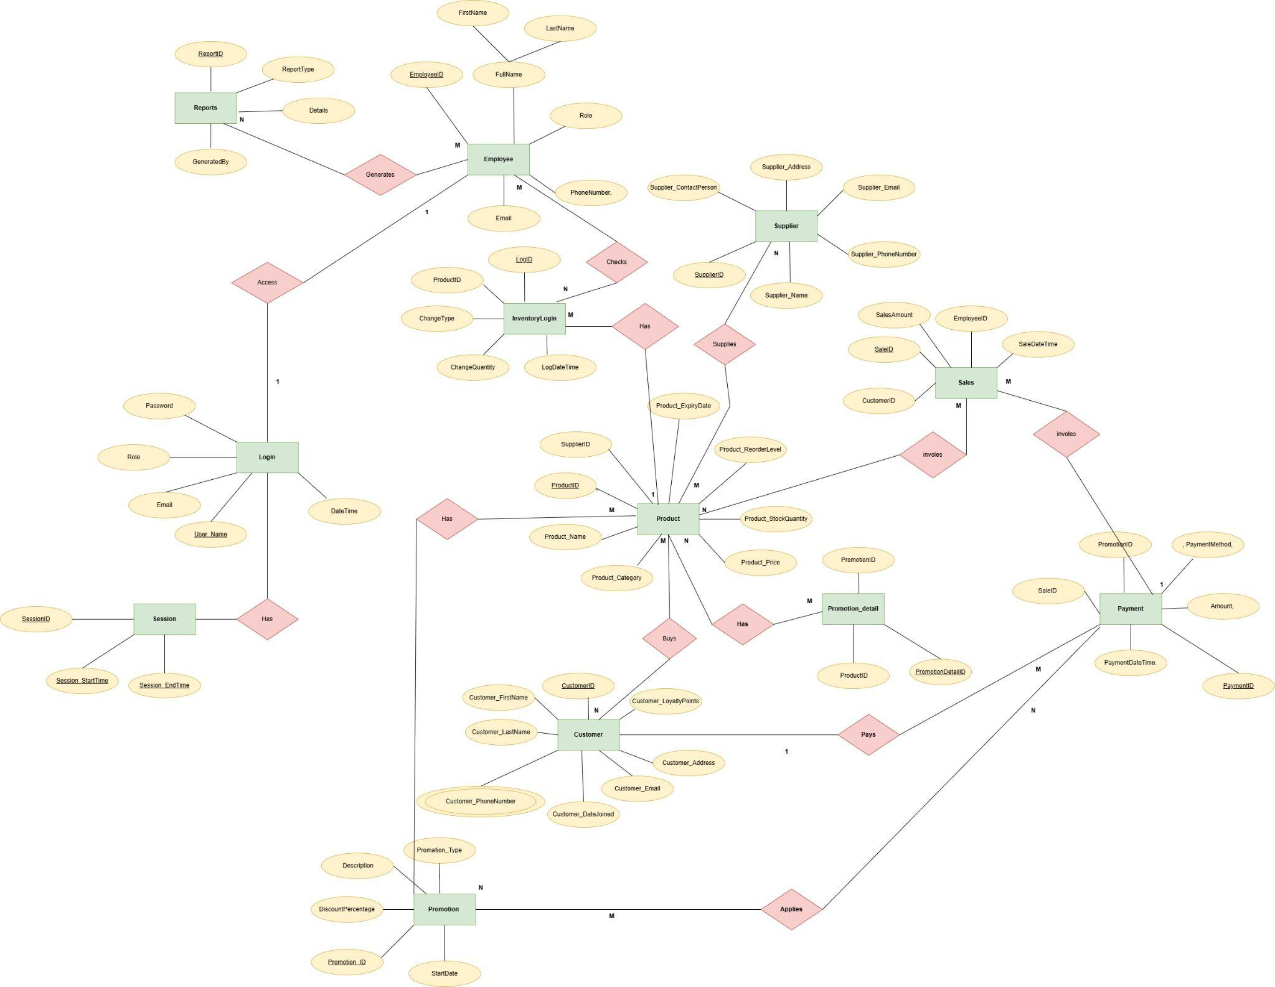

**Additional Assumption**

1. Users may have different roles (e.g., Admin, Employee)
2. Products have associated restock levels and expiration dates, assuming perishability for some products.
3. Payments are tracked separately using PaymentID, with details including Amount, PaymentMethod, and PaymentDateTime.
4. Supplier details are maintained for restocking purposes, and each product can be linked to a specific supplier.

**Relational Mapping**

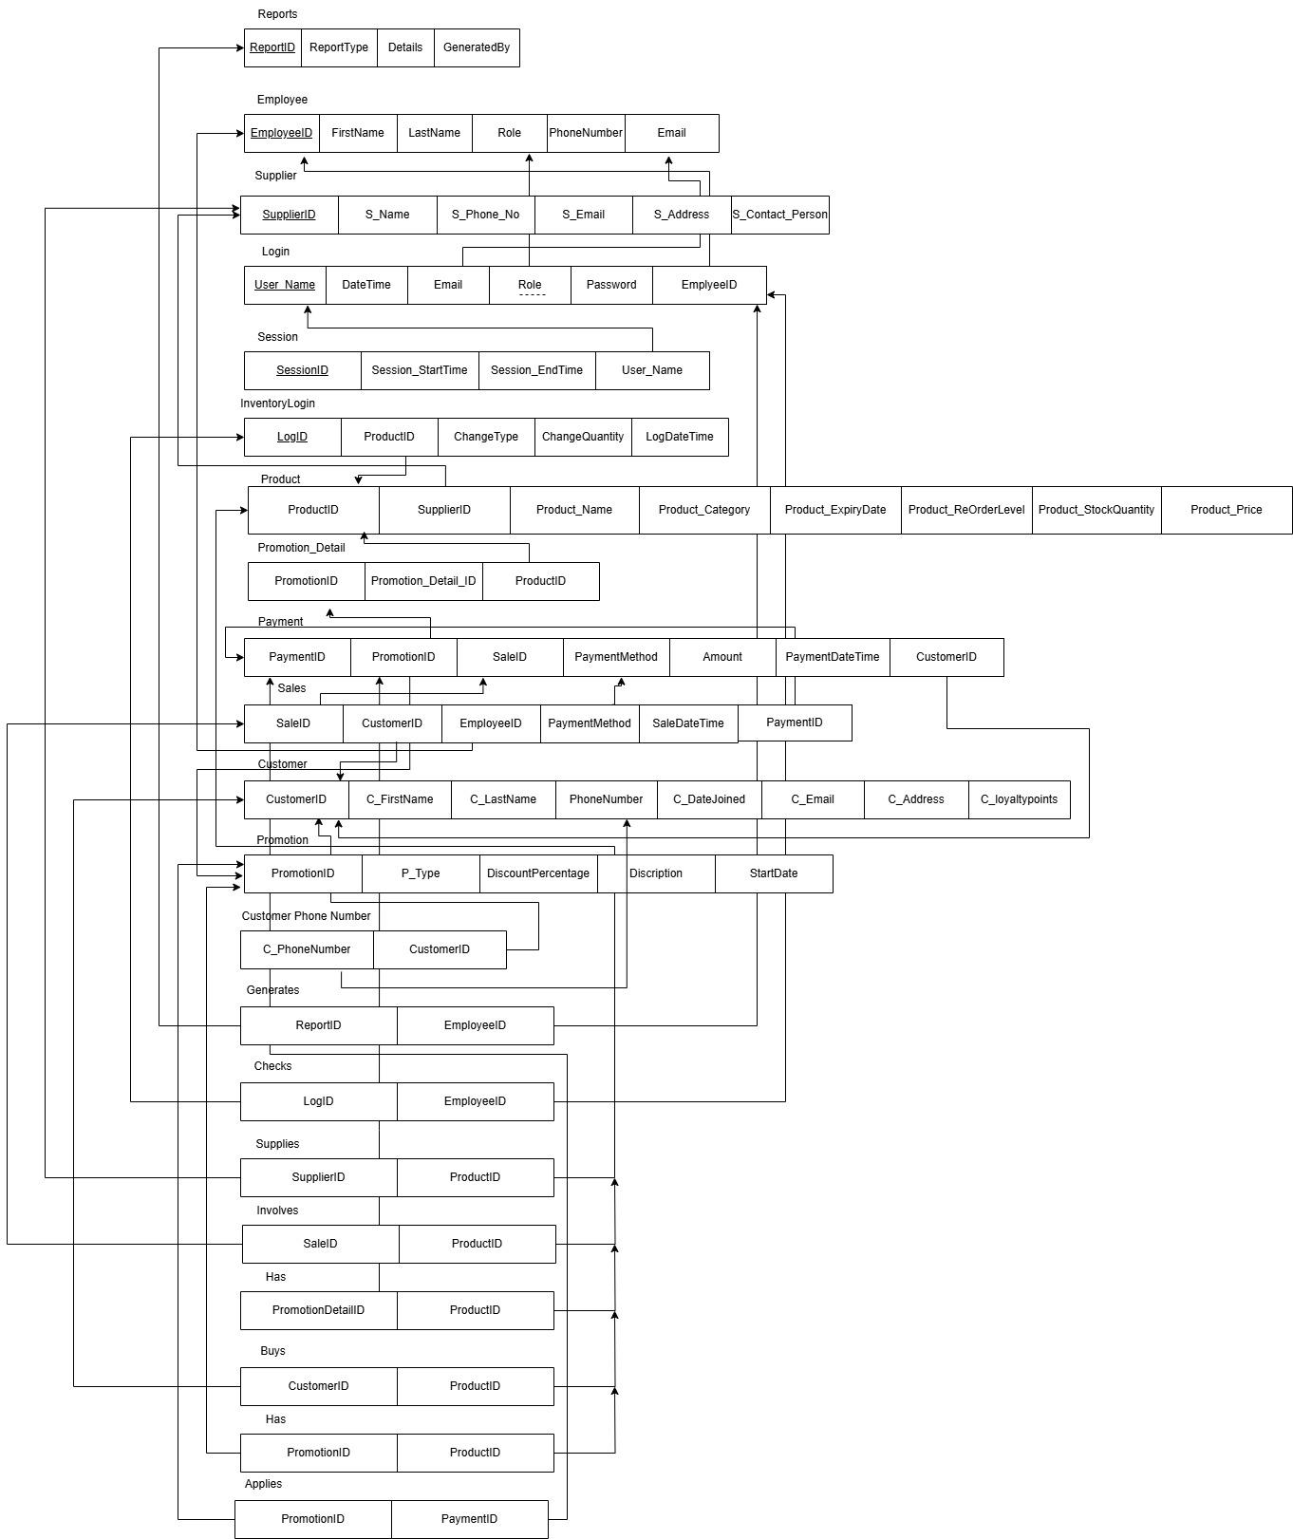

**Data Normalization**

***1NF (First Normal Form)***

**Customer Table**

| **CustomerID** | **Firstname** | **Lastname** | **PhoneNumber** | **Email** | **LoyaltyPoints** |
| --- | --- | --- | --- | --- | --- |

| **DateJoined** |
| --- |

**CustomerAudit Table**

| **AuditID** | **CustomerID** | **FirstName** | **LastName** | **DeletedAt** |
| --- | --- | --- | --- | --- |

**Department Table**

| **DepartmentID** | **DepartmentName** |
| --- | --- |

**Discount Table**

| **DiscountID** | **DiscountName** | **DiscountType** | **DiscountValue** | **StartDate** |
| --- | --- | --- | --- | --- |

| **EndDate** | **ProductID** |
| --- | --- |

**Employee Table**

| **EmployeeID** | **FirstName** | **LastName** | **Email** | **PhoneNumber** | **HireDate** |
| --- | --- | --- | --- | --- | --- |

| **JobID** | **Salary** | **ManagerID** | **DepartmentID** |
| --- | --- | --- | --- |

**Report Table**

| **ReportID** | **ReportType** | **ReportDate** | **TotalSales** | **TotalDiscounts** |
| --- | --- | --- | --- | --- |

| **TopSellingProduct** |
| --- |

**Sales Table**

| **SalesID** | **SaleDateTime** | **CustomerID** | **TotalAmount** |
| --- | --- | --- | --- |

**SalesDetails Table**

| **SaleDetailID** | **SaleID** | **ProductID** | **QuantitySold** | **SellingPrice** | **DiscountApplied** |
| --- | --- | --- | --- | --- | --- |

| **TotalPrice** |
| --- |

**Stock Table**

| **ProductID** | **ProductName** | **Category** | **UnitPrice** | **CostPrice** | **QuantityInStock** |
| --- | --- | --- | --- | --- | --- |

| **ReorderLevel** | **LastRestocked** | **SupplierID** |
| --- | --- | --- |

**Suppliers Table**

| **SupplierID** | **SupplierName** | **ContactInfo** |
| --- | --- | --- |

***Second Normal Form (2NF)***

**Customer Table**

| **CustomerID** | **Firstname** | **Lastname** | **PhoneNumber** | **Email** | **DateJoined** |
| --- | --- | --- | --- | --- | --- |

No partial dependencies exist, so it already satisfies **2NF**.

**CustomerLoyalty Table**

| **CustomerID** | **LoyaltyPoints** |
| --- | --- |

The LoyaltyPoints attribute depends only on CustomerID

**CustomerAudit Table**

| **AuditID** | **CustomerID** | **DeletedAt** |
| --- | --- | --- |

No partial dependencies exist, so it already satisfies **2NF**.

**Department Table**

| **DepartmentID** | **DepartmentName** |
| --- | --- |

No partial dependencies exist, so it already satisfies **2NF**.

**Employee Table**

| **EmployeeID** | **FirstName** | **LastName** | **Email** | **PhoneNumber** | **HireDate** |
| --- | --- | --- | --- | --- | --- |

| **JobID** | **Salary** | **ManagerID** | **DepartmentID** |
| --- | --- | --- | --- |

No partial dependencies exist, so it already satisfies **2NF**.

**Discount Table**

| **DiscountID** | **DiscountName** | **StartDate** | **EndDate** |
| --- | --- | --- | --- |

DiscountValue depended only on DiscountType

**DiscountType Table**

| **DiscountTypeID** | **DiscountType** | **DiscountValue** |
| --- | --- | --- |

If the Discount table has product-specific discounts

**Sales Table**

| **SalesID** | **SaleDateTime** | **CustomerID** | **TotalAmount** |
| --- | --- | --- | --- |

**SalesDetails Table**

| **SaleDetailID** | **SaleID** | **ProductID** | **QuantitySold** | **SellingPrice** | **DiscountApplied** |
| --- | --- | --- | --- | --- | --- |

| **TotalPrice** |
| --- |

**Stock Table**

| **ProductID** | **ProductName** | **Category** | **UnitPrice** | **CostPrice** | **QuantityInStock** |
| --- | --- | --- | --- | --- | --- |

| **ReorderLevel** | **LastRestocked** | **SupplierID** |
| --- | --- | --- |

**Suppliers Table**

| **SupplierID** | **SupplierName** | **ContactInfo** |
| --- | --- | --- |

***Third Normal Form (2NF)***

**Customer Table**

| **CustomerID** | **Firstname** | **Lastname** | **PhoneNumber** | **Email** | **DateJoined** |
| --- | --- | --- | --- | --- | --- |

**CustomerLoyalty Table**

| **CustomerID** | **LoyaltyPoints** |
| --- | --- |

**CustomerAudit Table**

| **AuditID** | **CustomerID** | **DeletedAt** |
| --- | --- | --- |

**Department Table**

| **DepartmentID** | **DepartmentName** |
| --- | --- |

**Employee Table**

| **EmployeeID** | **FirstName** | **LastName** | **Email** | **PhoneNumber** | **HireDate** |
| --- | --- | --- | --- | --- | --- |

| **JobID** | **Salary** |
| --- | --- |

The Employee table has a dependency between ManagerID and DepartmentID

**Manager Table**

| **ManagerID** | **DepartmentID** |
| --- | --- |

**Discount Table**

| **DiscountID** | **DiscountName** | **StartDate** | **EndDate** |
| --- | --- | --- | --- |

DiscountValue depended only on DiscountType

**DiscountType Table**

| **DiscountTypeID** | **DiscountType** | **DiscountValue** |
| --- | --- | --- |

If the Discount table has product-specific discounts

**Sales Table**

| **SalesID** | **SaleDateTime** | **CustomerID** | **TotalAmount** |
| --- | --- | --- | --- |

**SalesDetails Table**

| **SaleDetailID** | **SaleID** | **ProductID** | **QuantitySold** | **SellingPrice** | **DiscountApplied** |
| --- | --- | --- | --- | --- | --- |

| **TotalPrice** |
| --- |

**Stock Table**

| **ProductID** | **ProductName** | **Category** | **UnitPrice** | **CostPrice** | **QuantityInStock** |
| --- | --- | --- | --- | --- | --- |

| **ReorderLevel** | **LastRestocked** | **SupplierID** |
| --- | --- | --- |

**Suppliers Table**

| **SupplierID** | **SupplierName** | **ContactInfo** |
| --- | --- | --- |

**Report Table**

| **ReportID** | **ReportTypeID** | **ReportDate** |
| --- | --- | --- |

**ReportType Table**

| **ReportTypeID** | **ReportType** | **TotalSales** | **TotalDiscounts** | **TopSellingProduct** |
| --- | --- | --- | --- | --- |

**Data Dictionary**

**Customer Table**

| **Field Name** | **Data Type** | **Size** | **Constraints** | **Description** | **Example** |
| --- | --- | --- | --- | --- | --- |
| CustomerID | INT | N/A | PRIMARY KEY | Unique identifier for each customer. | 101 |
| FirstName | VARCHAR | 50 | NOT NULL | First name of the customer. | Nohim |
| LastName | VARCHAR | 50 | NOT NULL | Last name of the customer. | Senanayake |
| PhoneNumber | VARCHAR | 10 | UNIQUE, NOT NULL | Contact number of the customer. | +94 0778552345 |
| Email | VARCHAR | 100 | UNIQUE, NOT NULL | Email address of the customer. | nohim.senanayake@gmail.com |
| DateJoined | DATE | N/A | NOT NULL | Date when the customer joined. | 2024-12-20 |

**CustomerLoyalty Table**

| **Field Name** | **Data Type** | **Size** | **Constraints** | **Description** | **Example** |
| --- | --- | --- | --- | --- | --- |
| CustomerID | INT | N/A | PRIMARY KEY, FK | References Customer.CustomerID. | 10 |
| LoyaltyPoints | INT | N/A | DEFAULT 0 | Loyalty points accumulated by the customer. | 150 |

**CustomerAudit Table**

| **Field Name** | **Data Type** | **Size** | **Constraints** | **Description** | **Example** |
| --- | --- | --- | --- | --- | --- |
| AuditID | INT | N/A | PRIMARY KEY | Unique identifier for each audit entry. | 23 |
| CustomerID | INT | N/A | FK | References Customer.CustomerID. | 12 |
| DeletedAt | DATETIME | N/A | NOT NULL | Date and time when the record was deleted | 2024-12-01 14:30:00 |

**Department Table**

| **Field Name** | **Data Type** | **Size** | **Constraints** | **Description** | **Example** |
| --- | --- | --- | --- | --- | --- |
| DepartmentID | INT | N/A | PRIMARY KEY | Unique identifier for each department. | 10 |
| DepartmentName | VARCHAR | 100 | NOT NULL | Name of the department. | Sales |

**Employee Table**

| **Field Name** | **Data Type** | **Size** | **Constraints** | **Description** | **Example** |
| --- | --- | --- | --- | --- | --- |
| EmployeeID | INT | N/A | PRIMARY KEY | Unique identifier for each employee. | 20 |
| FirstName | VARCHAR | 50 | NOT NULL | First name of the employee. | Nohim |
| LastName | VARCHAR | 50 | NOT NULL | Last name of the employee. | Senanayake |
| Email | VARCHAR | 100 | UNIQUE, NOT NULL | Email address of the employee. | nohim.senanayake@company.com |
| PhoneNumber | VARCHAR | 10 | UNIQUE, NOT NULL | Contact number of the employee. | +94 0778552345 |
| HireDate | DATE | N/A | NOT NULL | Date when the employee was hired. | 2022-08-01 |
| JobID | INT | N/A | FK | References the job role in the Job table. | 3 |
| Salary | DECIMAL(10,2) | N/A | NOT NULL | Salary of the employee. | 50000.00 |
| ManagerID | INT | N/A | FK | References Manager.ManagerID | 342 |

**Manager Table**

| **Field Name** | **Data Type** | **Size** | **Constraints** | **Description** | **Example** |
| --- | --- | --- | --- | --- | --- |
| ManagerID | INT | N/A | PRIMARY KEY | Unique identifier for each manager. | 4 |
| DepartmentID | INT | N/A | FK | References Department.DepartmentID. | 10 |

**Discount Table**

| **Field Name** | **Data Type** | **Size** | **Constraints** | **Description** | **Example** |
| --- | --- | --- | --- | --- | --- |
| DiscountID | INT | N/A | PRIMARY KEY | Unique identifier for each discount. | 01 |
| DiscountName | VARCHAR | 250 | NOT NULL | Name of the discount. | Black Friday Sale |
| DiscountType | VARCHAR | 50 | NOT NULL | Type of the discount (e.g., Percentage, Flat). | Percentage |
| StartDate | DATE | N/A | NOT NULL | Start date of the discount. | 2024-11-25 |
| EndDate | DATE | N/A | NOT NULL | End date of the discount. | 2024-11-30 |

**Sales Table**

| **Field Name** | **Data Type** | **Size** | **Constraints** | **Description** | **Example** |
| --- | --- | --- | --- | --- | --- |
| SaleID | INT | N/A | PRIMARY KEY | Unique identifier for each sale. | 12 |
| SaleDateTime | DATETIME | N/A | NOT NULL | Date and time of the sale. | 2024-12-20 15:45:00 |
| CustomerID | INT | N/A | FK | References Customer.CustomerID. | 01 |
| TotalAmount | DECIMAL(10,2) | N/A | NOT NULL | Total amount of the sale. | 1000.00 |

**SalesDetails Table**

| **Field Name** | **Data Type** | **Size** | **Constraints** | **Description** | **Example** |
| --- | --- | --- | --- | --- | --- |
| SaleDetailID | INT | N/A | PRIMARY KEY | Unique identifier for each sale detail. | 135 |
| SaleID | INT | N/A | FK | References Sales.SaleID. | 24 |
| ProductID | INT | N/A | FK | References Stock.ProductID | 13 |
| QuantitySold | INT | N/A | NOT NULL | Quantity of the product sold. | 3 |
| SellingPrice |  | N/A | NOT NULL | Selling price of the product per unit. | 150.30 |
| TotalPrice | DECIMAL(10,2) | N/A | NOT NULL | Total price for the line item | 300.50 |

**Stock Table**

| **Field Name** | **Data Type** | **Size** | **Constraints** | **Description** | **Example** |
| --- | --- | --- | --- | --- | --- |
| ProductID | INT | N/A | PRIMARY KEY | Unique identifier for each product. | 156 |
| ProductName | VARCHAR | 100 | NOT NULL | Name of the product. | Apple Juice |
| Category | VARCHAR | 50 | NULLABLE | Category of the product. | Beverages |
| UnitPrice | DECIMAL(10,2) | N/A | NOT NULL | Price of the product per unit. | 450.00 |
| CostPrice | DECIMAL(10,2) | N/A | NOT NULL | Purchase price of the product. | 200.00 |
| QuantityInStock | INT | N/A | NOT NULL | Current quantity of the product in stock. | 100 |

**Supplier Table**

| **Field Name** | **Data Type** | **Size** | **Constraints** | **Description** | **Example** |
| --- | --- | --- | --- | --- | --- |
| SupplierID | INT | N/A | PRIMARY KEY | Unique identifier for each supplier. | 13 |
| SupplierName | VARCHAR | 100 | NOT NULL | Name of the supplier. | ABC Supplies Ltd. |
| ContactInfo | VARCHAR | 255 | NOT NULL | Contact details of the supplier. | +94 0778552345;  nohim.senanayake@company.com |

*Section 2*

**Table Statements with Constraints**

1. **Customer Table**

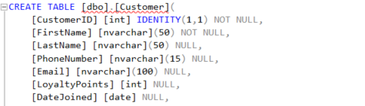

Constraints added to the **Customer Table**

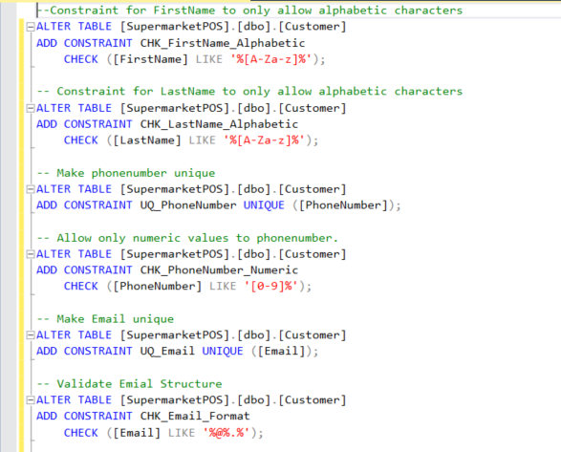

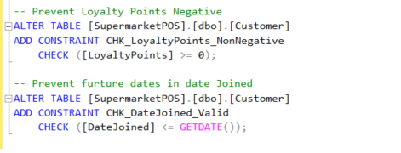

1. **CustomerAudit Table With Constraints**

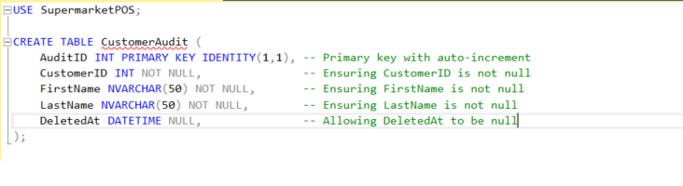

1. **Department Table With Constraints**

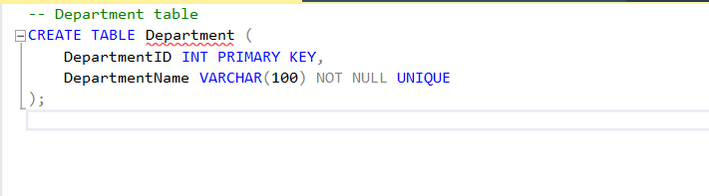

1. **Discount Table**

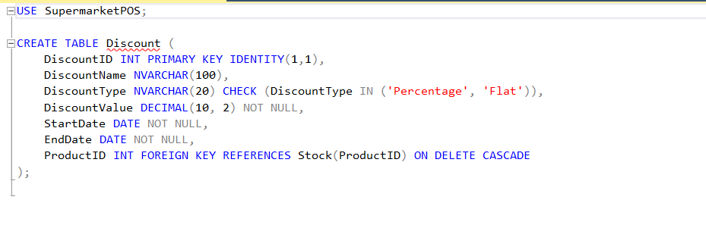

Constraints added to the **Discount Table**

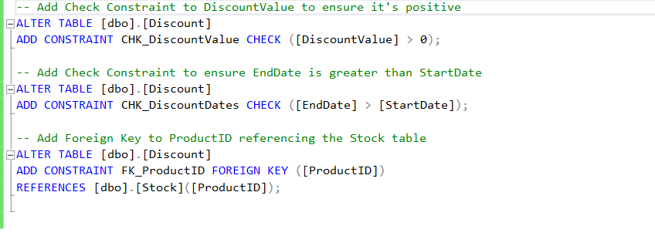

1. **Employee Table With Constraints**

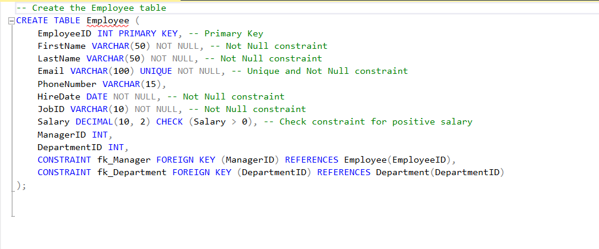

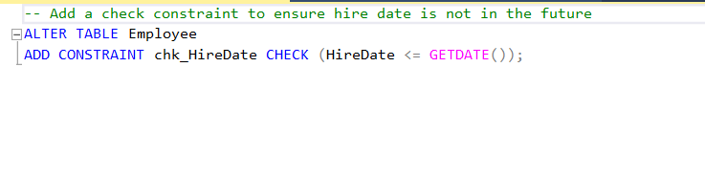

1. **Report Table**

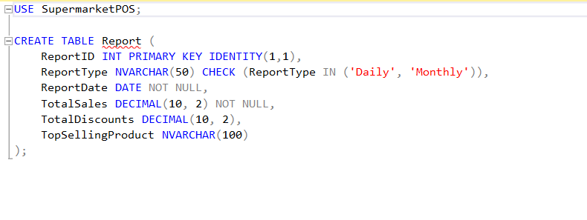

Constraints added to the **Report Table**

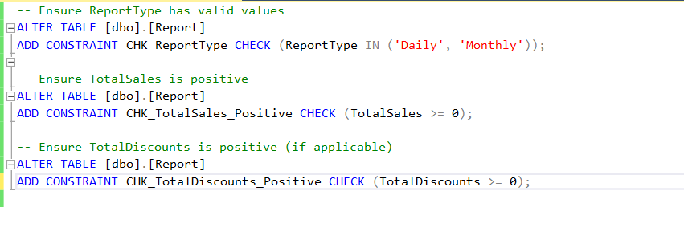

1. **Sales Table**

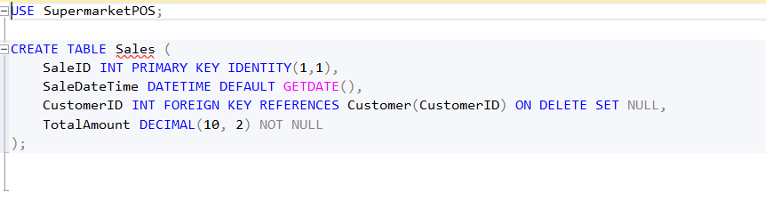

Constraints added to the **Sales Table**

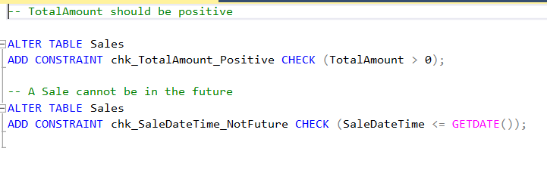

1. **Salesdetails Table With Constraints**

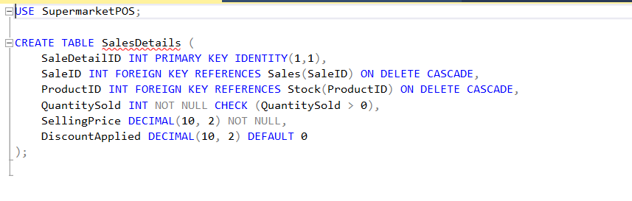

1. **Stock Table**

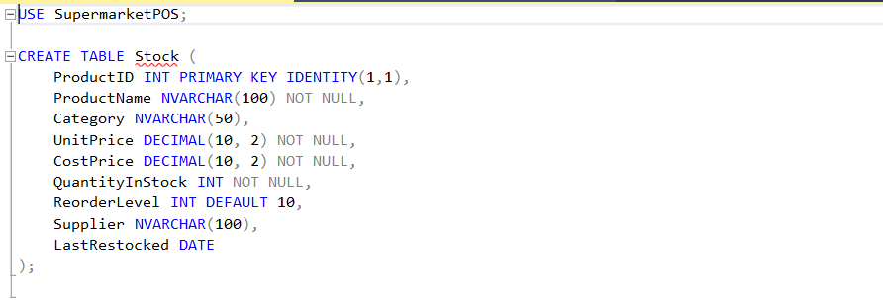

Constraints added to **Stock Table**

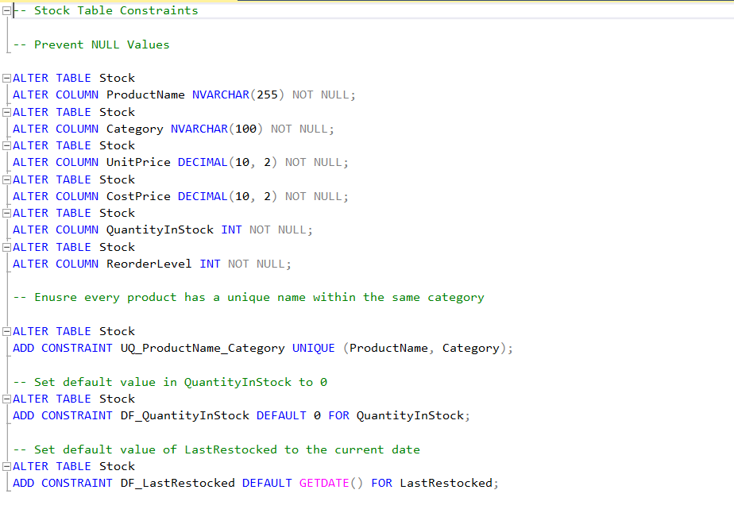



**Supplier Table With Constraints**

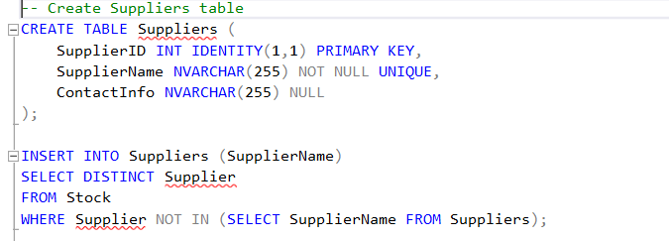

**Database Diagram**

**Screenshots With Meaningful Sample**

**Trigger Statements**

1. Records deleted customers in CustomerAudit Table when a customer is removed from the Customer Table.

It is important to keep records of every valid and invalid customers in a

Supermarket POS system.

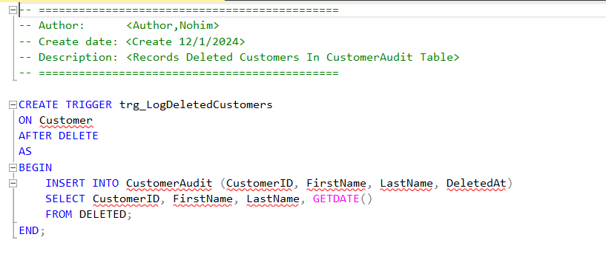

1. Apply Discount On Sale Trigger: when a sale happens. According to the discount amount in the discount table to a specific product, The Total Price will change in the record of the Sales Table

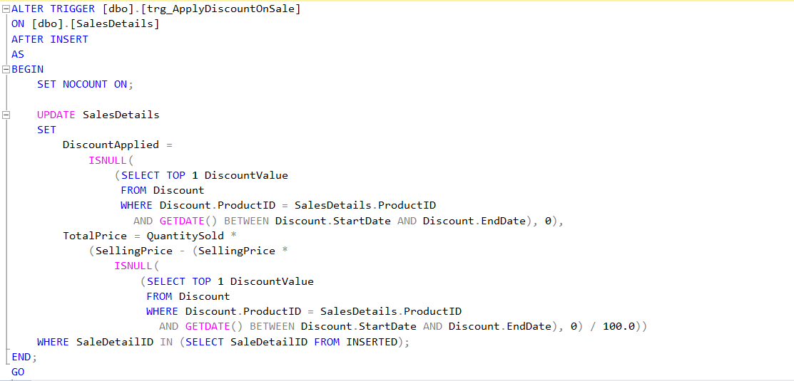

**Function Statements**

1. Calculate Total Revenue Of The Day

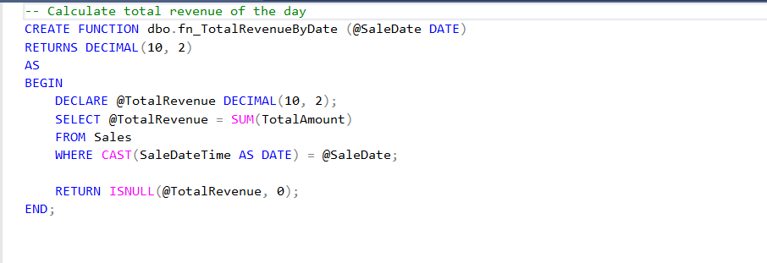

1. Loyalty Points Rewarded (10 points for every Rs100 Spent)

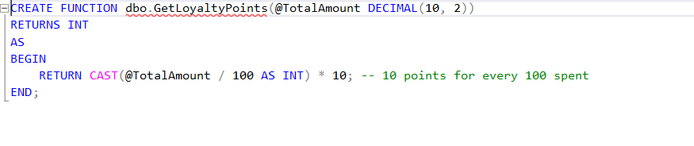

**View Statements**

1. View Customer Info such as their loyalty points, and total spending from the Sales table.

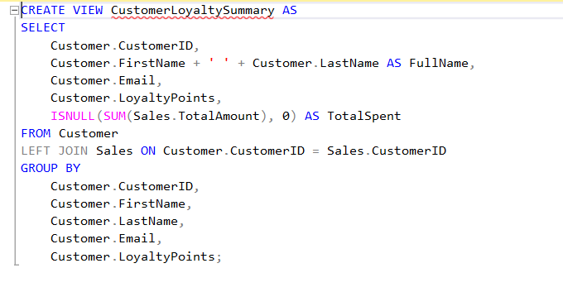

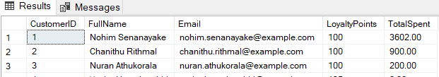

1. View for Top-Selling Products

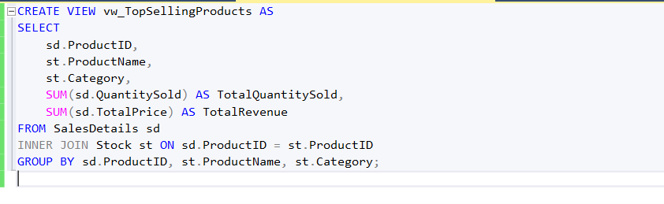

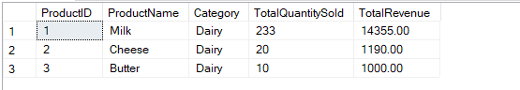

**Procedure Statements**

1. Update the quantity of a product in stock.

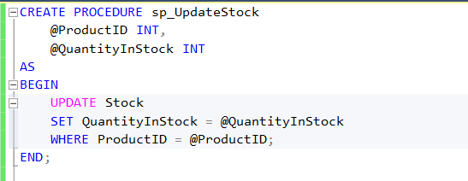

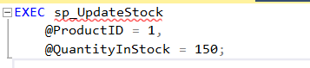

2 . Procedure to Retrieve Customer Purchase History

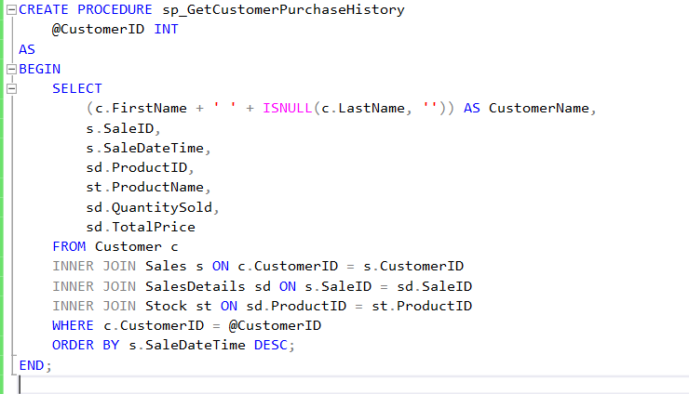

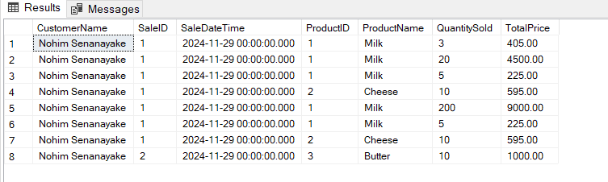

**Critical Appraisal of the Solution**

**Strengths**

* The database has all the core needs of a supermarket POS system such as customer management such as **customer management, stock management, discount management, sales tracking, and detailed reporting**.
* It has a Customer Loyalty program which helps to keep the retention of the customer.
* It has normalized to the third normalization form which ensure that the database has a robust and efficient database design.
* Data redundancy has been reduced by proper use of constraints and keys.
* Automations have been done using trigger in instances such as customer deletion in an audit table and adjusting prices automatically based on discounts.
* Critical operations such as stock updates and calculating revenue, streamline common tasks are handled by procedures and functions.
* Daily and monthly reports are generated.
* Inventory optimization is made easy by allowing to view top selling products.
* Role based user access improves security.

**Shortcomings and Recommendations:**

* Issue : The system mostly focuses on current supermarket requirements but lacks Ai integrated technologies.

Resolution : Plan for adding predictive analytics using Ai for sales forecasting.

* Issue : While payment tracking is present, features like digital wallet interrogation are not available.

Resolution : Add APIs for payment handling

* Issue : Reporting currently rely on static snapshots rather than dynamic real time data.
* Resolution : Implement real time data streaming.
* Issue : The database has advanced security measures like encryption of sensitive data.

Resolution : Implement security protocols.

**Future implementation**

**Expanding the application for mobile users**

* By expanding the application to mobile platforms managers and employees will have on the go access by managers and employees. This will enable stock monitoring, sales tracking, and customer engagement via loyalty programs.

**Advanced analytics and AI integration**

* Adding predictive analytics to forecast sales trends, customer behavior, and stock requirements which will improve decision making.

**Cloud Deployment**

* Move the application to a cloud based infrastructure to increase scalability.

**Using IOT technology**

* Implement IOT devices for automation of stock updates and tracking.

**Localization**

* Provide language support options